 | Testing and Training Center of Farm Machinery  Department of Farm Machinery and Power Engineering  College of Agricultural Engineering and Technology  Junagadh Agricultural University  JUNAGADH – 362 001 (GUJARAT) | 
P | Phone : (0285) 2672080-90, Ext. 390 & 484; Fax : (0285) 2671018

SPECIFICATION SHEET OF TRACTOR OPERATED ROTARY MULCHER

1.0 | General
 | Name
 | Type
 | Make
 | Serial Number
 | Model
 | Year of manufacture
 | Name and address of manufacture
 | Selling price in India
 | Source of power
 | Recommended power of tractor, if tractor operated
 | Suitability

2 | Constructional Details:
2.1 | Main frame / Chassis:
 | a) | Type and material |  |  |  |  |  |  | :
 | b) | Size of box section(mm) |  |  |  |  |  |  | :
 | c) | Size of supporting flat (mm) |  |  |  |  |  |  | :
 | d) | Type of mounting box section |  |  |  |  |  |  | :
2.1.1 | Side support / plates:
 | a) |  | Number and material |  |  |  |  | :
 | b) |  | Thickness of plate (mm) |  |  |  |  | :
 | c) |  | Size (mm)
 |  |  | LHS |  |  |  |  | :
 |  |  | RHS |  |  |  |  | :
 | d) |  | Method of fixing |  |  |  |  | :
2.1.2 | Shield (cover):
 | a) |  | Type |  |  |  |  | :
 | b) |  | Size (mm) |  |  |  |  | :
 | c) |  | Thickness of sheet (mm) |  |  |  |  | :
 | d) |  | Method of mounting |  |  |  |  | :
2.2 | Trailing board/ Rear Safety guard / Rear Protection cover:
 | a) | Type and material |  |  |  |  |  | :
 | b) | Size of board (mm) |  |  |  |  |  | :
 | c) | Number of hinge |  |  |  |  |  | :
 | d) | Angle of trailing board |  |  |  |  |  | :
 | e) | Provision for locking |  |  |  |  |  | :
 | f) | Method of fixing |  |  |  |  |  | :
2.3 | Rotor shaft:
 | a) | Material |  |  |  |  |  | :
 | b) | Type and size (mm) of rotor axle |  |  |  |  |  | :
 | c) | No. and type of blade holder |  |  |  |  |  | :
 | d) | Size (mm) of holder |  |  |  |  |  | :
 | e) | No. of blades on each holder |  |  |  |  |  | :
 | f) | Total No. of blades |  |  |  |  |  | :
 | g) | Method of mounting blades on holder |  |  |  |  |  | :
 | h) | Distance between two holder (mm) |  |  |  |  |  | :
 | i) | Dia. of rotor with blades (mm) |  |  |  |  |  | :
 | j) | Method of fixing |  |  |  |  |  | :
2.4 | Blades (Refer Fig. 2):
 | a) |  |  | Number and Type |  |  |  | :
 | b) |  |  | Material |  |  |  | :
 | c) |  |  | Size (cm) |  |  |  | :
 | d) |  |  | Length and width of beveled edge (mm) |  |  |  | :
 | e) |  |  | No., size and spacing of the holes on each blade for fixing it to the flanges (mm) |  |  |  | :
 | f) |  |  | Arrangement of blades on the axle |  |  |  | :
 | g) |  |  | Speed of rotor shaft corresponding to the 540 rpm of PTO shaft (rpm) |  |  |  | :
 | h) |  |  | Peripheral speed of rotor blades (m/min) |  |  |  | :
 | i) |  |  | Other blade |  |  |  | :
2.5 | Mulch compacting mechanism / Skid / Leveller roller:
 | a) |  |  | Type and material |  |  | :
 | b) |  |  | Size (mm) |  |  | :
 | c) |  |  | Method of fixing |  |  | :
2.6 | Front safety guard:
 | a) |  |  | No., Type and material |  |  | :
 | b) |  |  | Size (mm) |  |  | :
 | c) |  |  | Method of mounting |  |  | :
2.7 | Type of hitch and its details :
 | a) |  |  | Type | :
 | b) |  |  | Constructional details | :
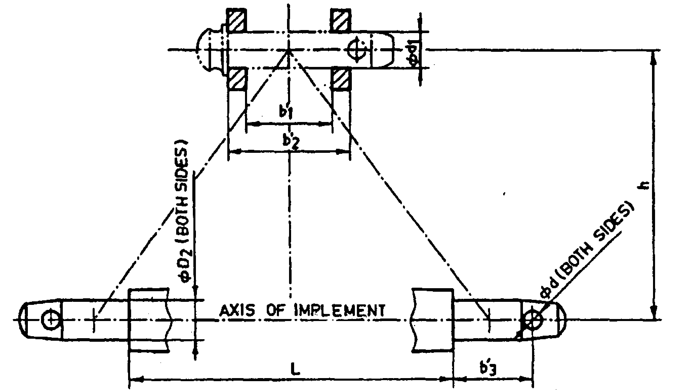
Fig. 1 : Implement Hitch Attachment

Sr. | Dimen.  (Refer Fig. 1) | Description | Dimensions as observed
Upper Hitch attachments
1 | - | Dia. of hitch pin
2 | d₁ | Dia. of hitch pin hole
3 | b’₁ | Width between inner faces of yoke
4 | b’₂ | Width between outer faces of yoke
Lower hitch points
5 | - | Dia. of hitch pin
6 | D₂ | Dia. of hitch pin hole
7 | b’₃ | Linch pin hole distance
8 | l | Lower hitch point span
Other dimensions
9 | d | Dia. of linch pin hole (upper hitch pin)
10 | d | Dia. of linch pin hole (lower hitch pin)
11 | h | Mast height

2.8 | Power transmission system:
 | a) |  | Method of transmission |  | :
2.8.1 |  | Splined end of Rotary mulcher input shaft (Refer Fig. 2):
Dimension of Implement Power Input Shaft As per IS: 4931-2006
Specification/ Notations  (Refer Fig.2) |  |  |  | Dimensions as per IS: 4931-2006 |  |  | Dimensions as observed
PTO Type 1/2/3 |  |  |  | Type-1/2/3
Nominal speed (rpm) |  |  |  | 540/1000/1000
Nominal dia.(mm) |  |  |  | 35/35/45
Number and type of splines |  |  |  | 6- straight splines/21 involutes/20 involutes
Dimensions (mm)
D Ø |  |  |  | 34.79+0.06
d Ø |  |  |  | 28.91+0.05, -0.15
B Ø |  |  |  | 29.40+0.1
A Ø |  |  |  | 8.3+0.1 (optional)
W |  |  |  | 8.53-8.60
a |  |  |  | 7
b |  |  |  | 25+0.5
c |  |  |  | 38
x |  |  |  | 30º
B |  |  |  | 76 (min)
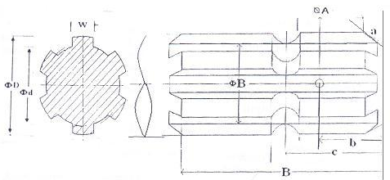
Fig. 2: Dimension of Implement Power Input Shaft
2.8.2 |  | Gear box assembly (primary reduction):
 |  | a) | Type |  | :
 |  | b) | No. of teeth on pinion |  | :
 |  | c) | No. of teeth on bevel gear |  | :
 |  | d) | Reduction ratio at gear box |  | :
 |  | e) | Oil capacity (L) |  | :
 |  | f) | Oil change period (hr) |  | :
 |  | g) | Recommended grade of oil |  | :
 |  | h) | Length of power transmission shaft (mm) (from gear box to secondary reduction unit |  | :
 |  | i) | Diameter of shaft (mm) |  | :
 |  | j) | Provision of breather |  | :
 |  | k) | No. of bearing |  | :
2.8.3 |  | Pulley box assembly (secondary reduction):
 |  | a) | Type |  | :
 |  | b) | Dia. of drive pulley gear |  | :
 |  | c) | Dia. of driven pulley gear |  | :
 |  | d) | Reduction ratio |  | :
 |  | e) | Dia. of idler pulley |  | :
 |  | f) | Oil capacity (L) |  | :
 |  | g) | Oil change period (hr) |  | :
 |  | h) | No. of bearing |  | :
2.8.4 |  | Propeller shaft (Refer Fig. 3) |  |  | :
 |  | a) | Type and material |  | :
 |  | b) | Length of shaft (mm) |  | :
 |  | c) | Mass of shaft (kg) |  | :
 |  | d) | Provision for locking |  | :
Propeller Shaft Insert Dimensions As per IS: 4931-2006
Sr. | Notations  (Refer Fig. 3) |  |  | Dimensions as per IS: 4931-2006 |  |  | Dimensions as observed
1 | D Ø |  |  | 34.93+0.03
2 | d Ø |  |  | 29.70+0.1
3 | W |  |  | 8.69 (min)
4 | B |  |  | 54 (min)

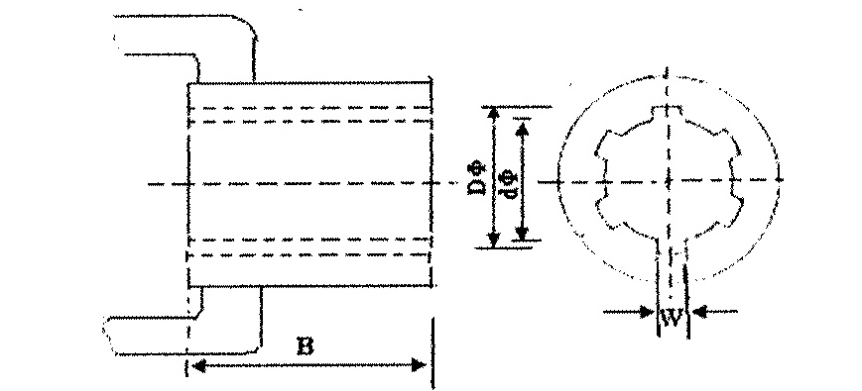
Fig. 3 : Propeller Shaft Insert Dimensions
2.8.5 |  | Safety clutch/device |  |  |  | :
 |  | a) |  | Length (mm) |  | :
 |  | b) |  | Dia. (mm) |  | :
 |  | c) |  | Pitch (mm) |  | :
3 | Overall Dimensions (mm):
 | a) |  | Length |  | :
 | b) |  | Width |  | :
 | c) |  | Height |  | :
 | d) |  | Mass, (kg) |  | :
4 | Color of Implement |  |  |  | :

Place: Date:
Signature : _________________________ Name : _________________________

Designation: ________________________

